## WiseOwlTutorials -- VBA notes

<http://www.youtube.com/watch?v=KHO5NIcZAc4&list=PLNIs-AWhQzckr8Dgmgb3akx_gFMnpxTN5&index=1>

**To rename a module change its name in the Property Window**

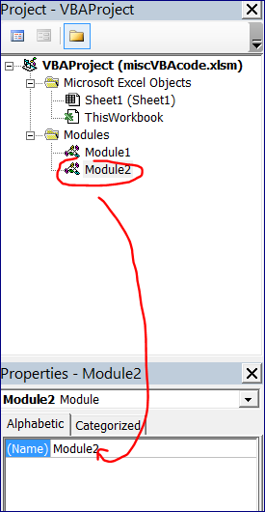

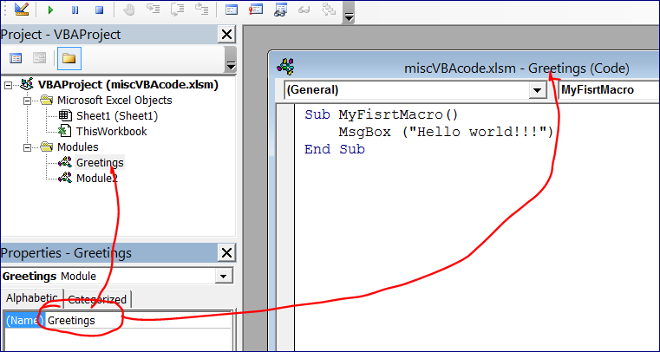

**Press F2 to get the Object Browser**

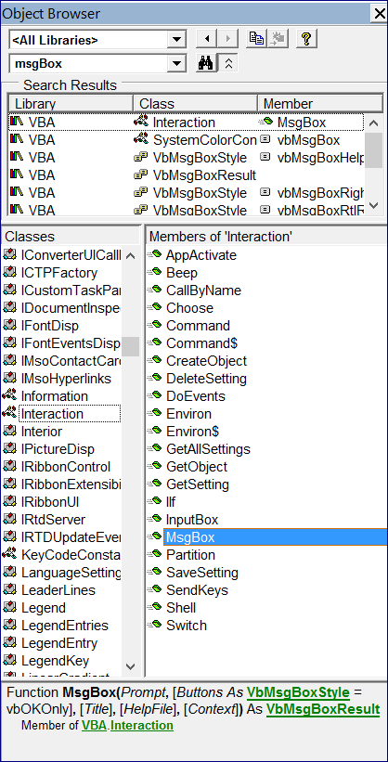

### Setting Up the VB Editor Fonts

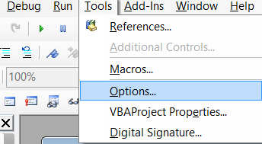

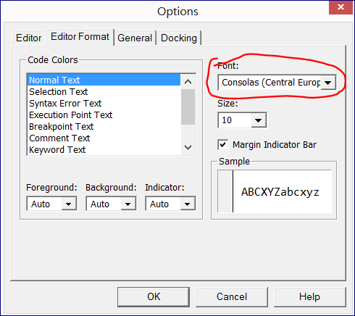

## Lesson #2 - Excel VBA Introduction - Writing Your First VBA Macro

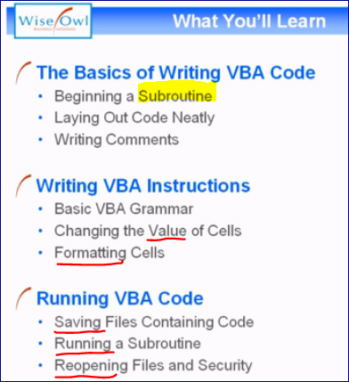

Add a space and a tab after the name of the subroutine for **better formatting**.

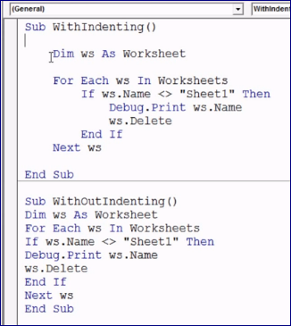

Sub CreateAndLabelNewSheet()

**REM** you can ALSO start a comment with a key word "Rem"

'Basic VBA sentence contains: thing.action or 'Object.Method()

'Create a new worksheet

Worksheets.Add()

**'add titles to cells**

'Object.Property = Value

Range("A1").Value = "Created by"

Range("A2").Value = "Created on"

Range("A3").Value = "Version"

**'add user values to cells**

Range("B1").Value = Environ("UserName")

Range("B2").Value = Date

Range("B3").Value = 1

**'format titles**

Range("A1:A3").Font.Color = vbBlue

Range("A1:A3").Interior.Color = rgbPaleTurquoise

End Sub

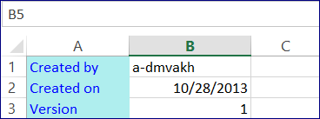

## Lesson #3 - Errors and Debugging

<http://www.youtube.com/watch?v=DlqKfYTgc9Q&list=PLNIs-AWhQzckr8Dgmgb3akx_gFMnpxTN5&index=3>

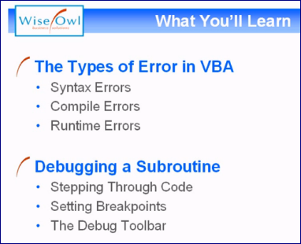

### 1. Syntax Error

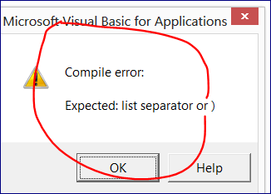

We can turn off the pop-up error message.

**Go to Tools 🡪 Options**

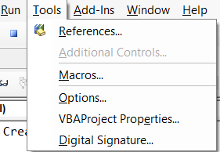

**Uncheck “Auto Syntax Check” 🡪 Ok**

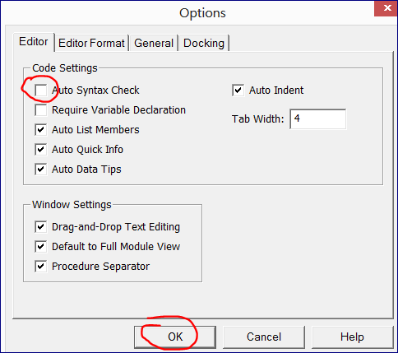

Now the wrong syntax will be highlighted only (without a message box)

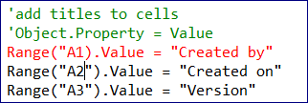

### 2. Compile Error

Occurs when all the code is grammatically correct by the error occurs during the run time of the code.

**We can click F5 or the icon.**

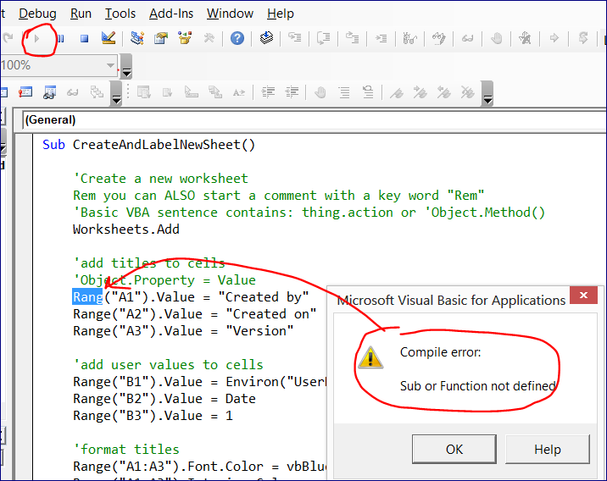

We can also compile the code without running it.

**Click Debug 🡪 Compile VBAProject**

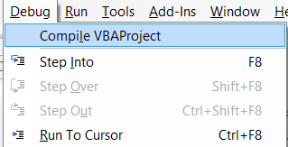

If in the code below I change the word “Date” to “Dat” the code will compile and run.

But instead of the current date I will get the nothing in the cell.

Because it doesn’t recognize the word Dat as a key word.

So, the compiler creates a variable with the name Dat and assigns it to null.

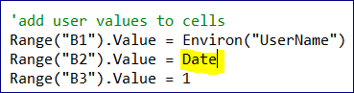

We can avoid getting this problem putting two keywords (“**Option Explicit**”) on top of the code:

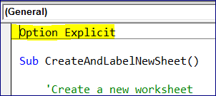

Now if we try to compile it we get a message: “Variable Not Defined”

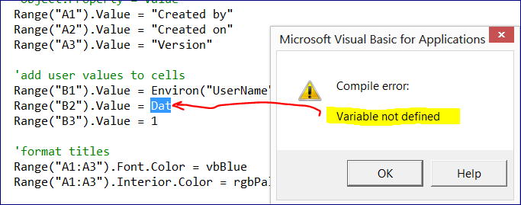

We can this option constantly ON in Tools 🡪 Options

**Check the box in “Require Variable Declaration”**

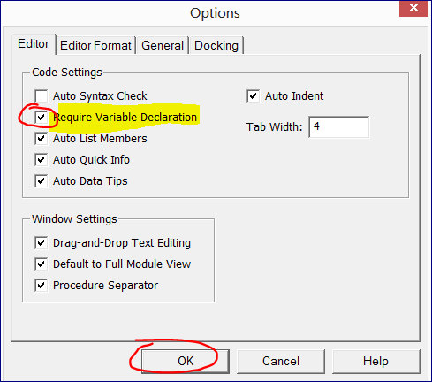

### 3. Run-Time Error

**For example, when we refer to a cell that doesn’t exist (“zzz1”)**

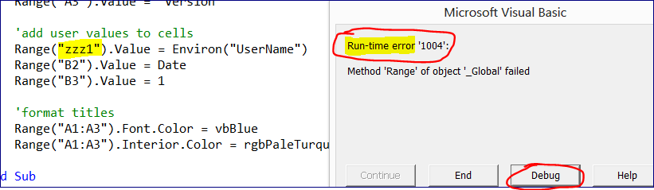

**If we click “Debug” it will show the line that caused the error.**

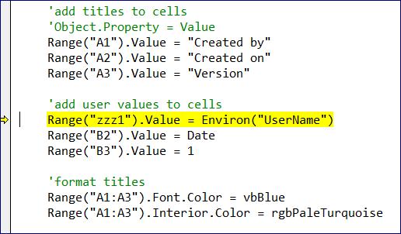

**The code was executed before the error (part1). If we fix the error we can RERUN the whole program again OR proceed with the execution from the stop point (F5).**

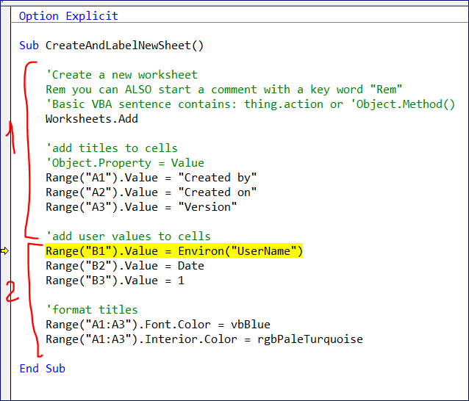

### Debugging Techniques

**Press F8 to go through your program step by step.**

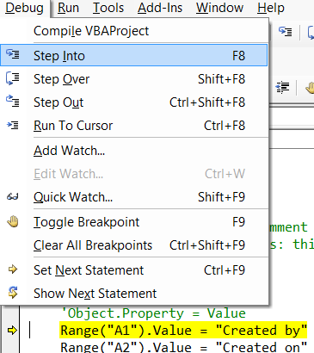

**To set a breakpoint press F9**

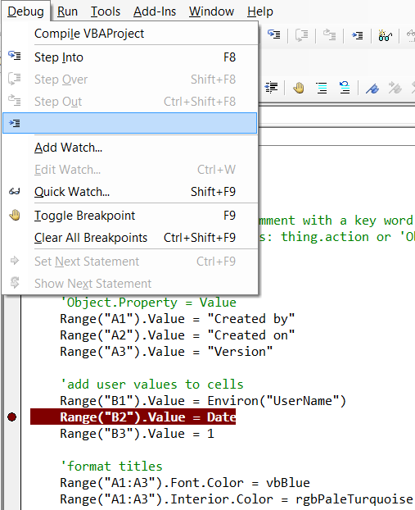

## Lesson #4 - Buttons, Toolbars and Keyboard Shortcuts

**Create a short cut**

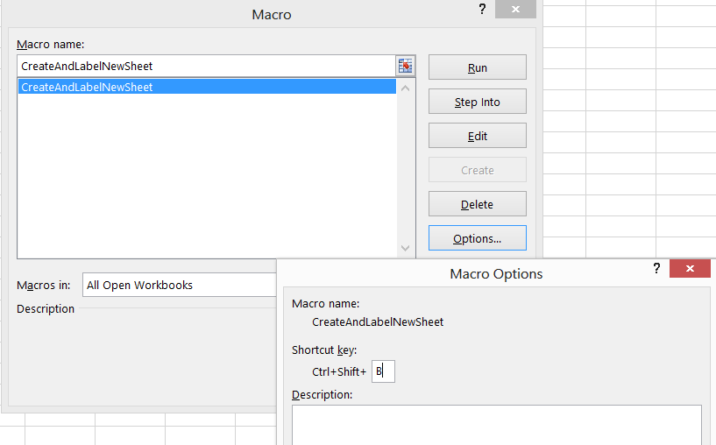

**Create a button attached to the Macro**

The Form Controls do not have an option to change a color.

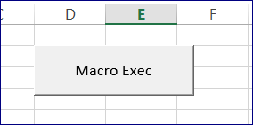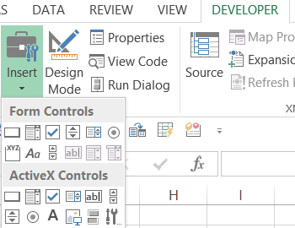

**But we can assign a macro to any drawn object.**

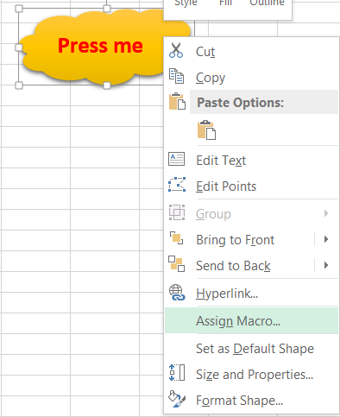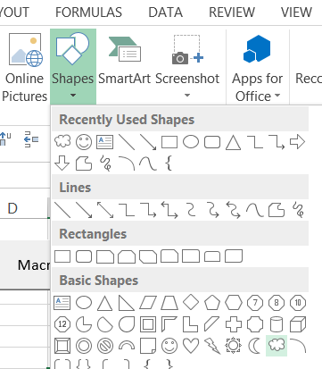

But those buttons are available on the sheet that you placed them only.

**We can, however, add buttons to Quick Access toolbar.**

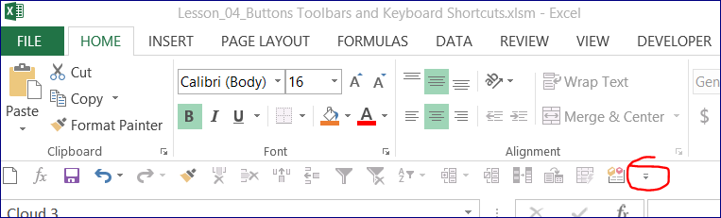

Select “More Commands”

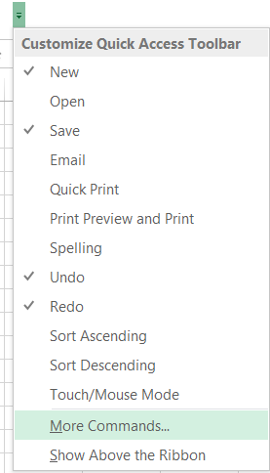

Select if it will be for ALL excel documents or just for this workbook.

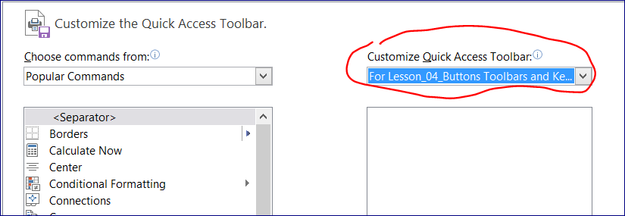

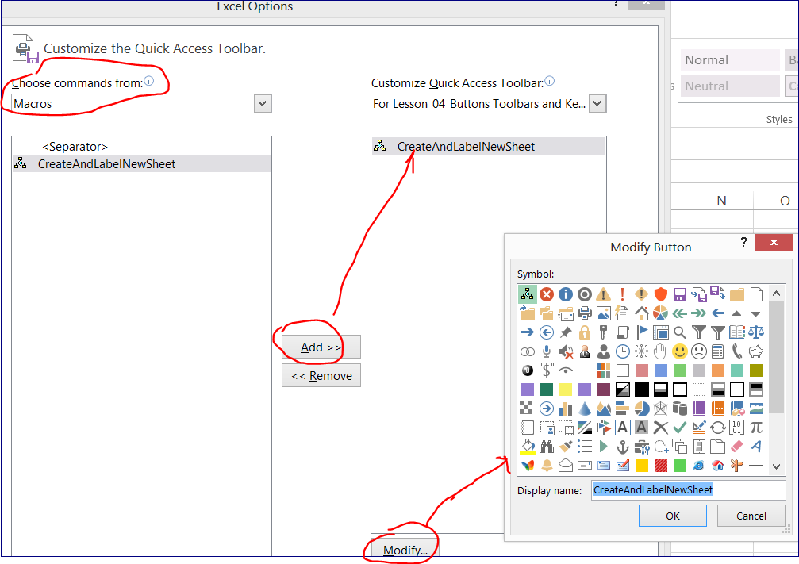

Now we assigned a new icon and put this icon into the **quick access tool bar.**

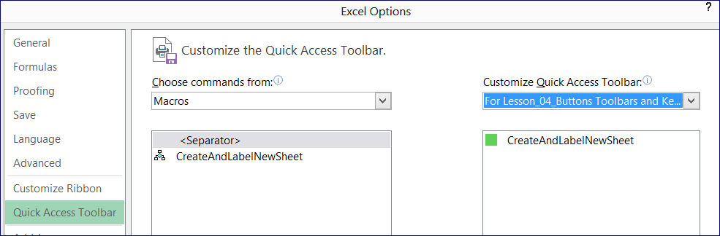



**We can add an extra tab**

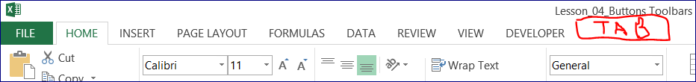

**Right-click on any of the tab and choose “Customize the ribbon”**

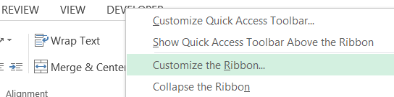

**Click “New Tab”**

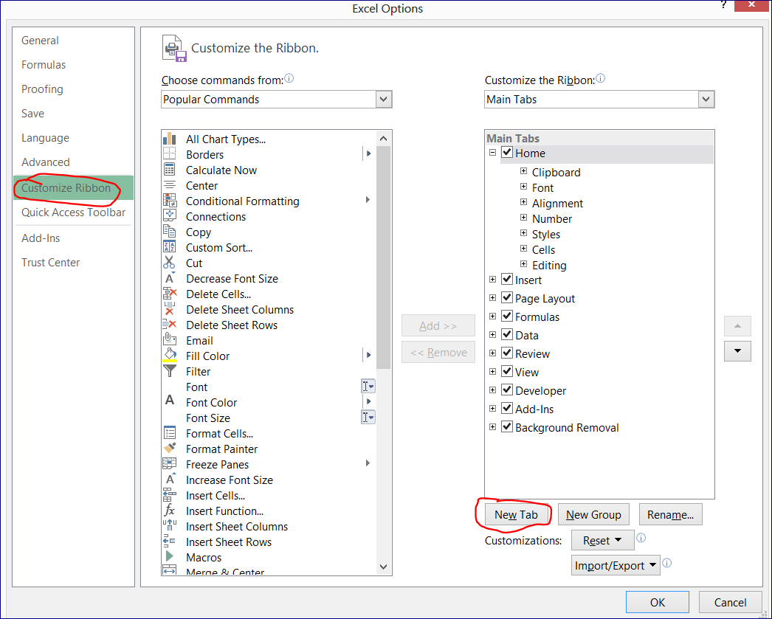

**Add DimMacros tab**

**Inside of this tab create a Basic Macro group**

**Add an existing macro to this group and rename it (to change the icon and name if needed)**

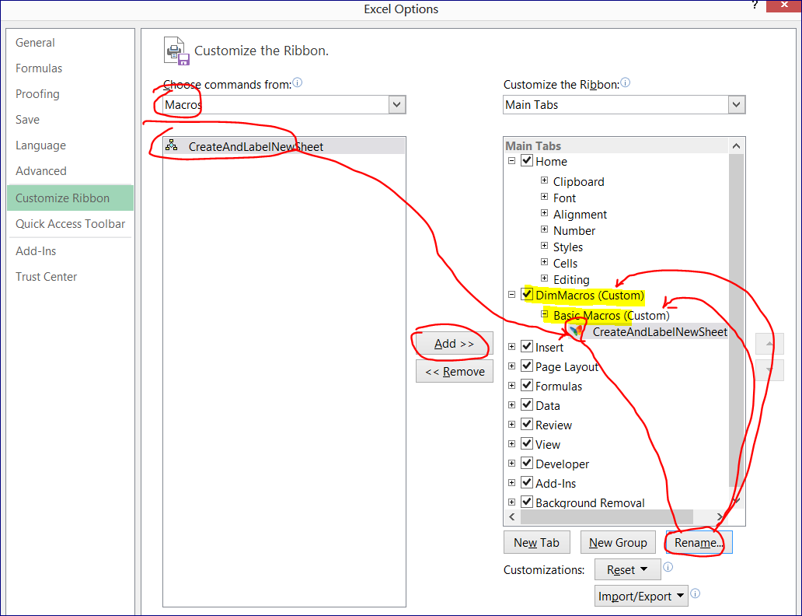

Now we have a new tab “DimMacros”

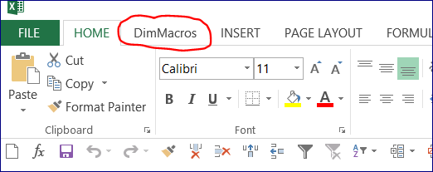

**Click on it to access the available macros**

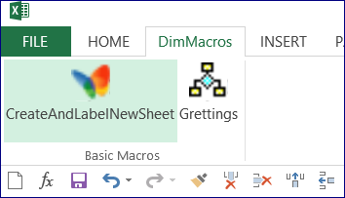

## Lesson #5 - Excel VBA Introduction - Selecting Cells (Range, Cells, Activecell, End, Offset)

You'll learn

* how to select cells by cell reference using the **Range** property,
* how to refer to cells by row and column number using the **Cells** property,
* and how to refer to the currently selected cell using the **Activecell** property.

We also cover how to select multiple cells and how to refer to range names as well as a variety of relative selection tricks such as

* using the **End** property to jump to the bottom of a list,
* using the **Offset** property to move a specific number of rows and columns,
* and how to select an **entire region of data** with one simple instruction.

Along the way you'll also learn several techniques for formatting and modifying cells, as well as how to copy and paste data in VBA.

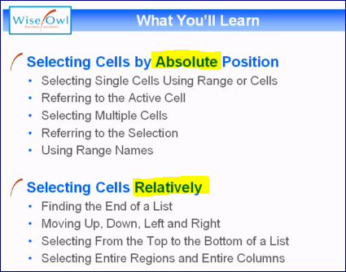

Option Explicit On

Sub SelectSingleCellByPosition()

'The most common way is to use "Range" keyword to select a single cell

Range("A13").Select()

'Select active cell and change it value

ActiveCell.Value = 11

'Using "Cells" allows to specify row and column numbers

Cells(13, 2).Select()

ActiveCell.Value = "The Lorax"

'Unusual but useful [C13]

'To insert dates we need to include them between two has tags #....#

' # mm / dd / yyyy #

[c13].Select()

ActiveCell.Value = #3/2/2012#

End Sub



### Selecting Cells on OTHER Worksheets

'Select relative worksheet, e.g. "sheet1"

Worksheets("Sheet1").Activate()

### Select cells in other workbooks

'Select relative WorkBook

Workbooks("Lesson_05_.xlsm").Activate()

### Changing cells without selecting them

Range("A14").Value = 14

Range("B14").Value = "Wreck it Ralph"

Range("C14").Value = #11/2/2012#

### Change Cells in Other WorkSheets

Sub ChangeCellValuesWithoutSelecting()

'Refer to cell on the Active Sheet

Range("A14").Value = 14

Range("B14").Value = "Wreck it Ralph"

Range("C14").Value = #11/2/2012#

'Refer to Worksheet --> Cell

Worksheets("Sheet2").Range("A14").Value = 14

Worksheets("Sheet2").Range("B14").Value = "Wreck it Ralph"

Worksheets("Sheet2").Range("C14").Value = #11/2/2012#

**'Refer to WorkBook --> Worksheet --> Cell**

Workbooks("Book5").Worksheets("Sheet1").Range("A14").Value = 14

Workbooks("Book5").Worksheets("Sheet1").Range("B14").Value = "Wreck it Ralph"

Workbooks("Lesson_05_.xlsm").Worksheets("Sheet1").Range("C14").Value = #11/2/2012#

End Sub

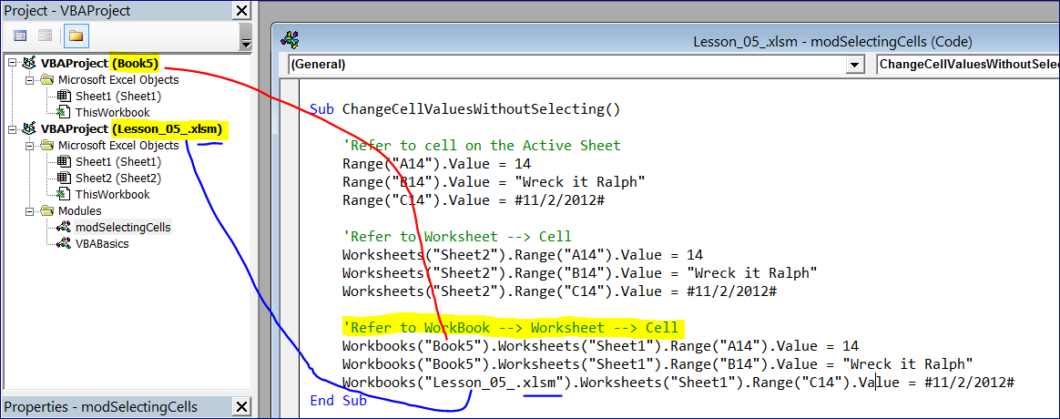

### Selecting Multiple Cells

'select a rectangular range (option #1)

Range("A1:C1").Select

Selection.Interior.Color = rgbDarkBlue

Range("A1:C1").Font.Color = rgbWhite

[A1:C1].Font.Size = 14

'select a rectangular range (option #2)

Range("A2", "C2").Interior.Color = rgbLightBlue

Range(Cells(2, 1), Cells(2, 3)).Font.Color = rgbDarkBlue

### Creating Range Names in Excel

**Range Name** is simply a label that refers to a single cell or a block of cells.

Select a range with column names you want to use as labels.

**Go to Formulas 🡪 Create From Selection**

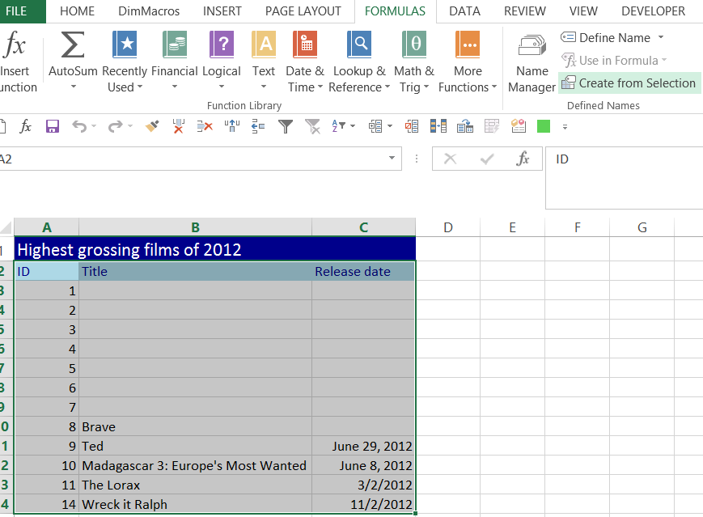

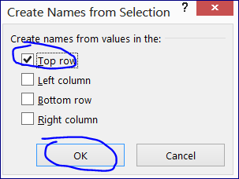

Now we have three Range Names: ID, Release_date, and Title

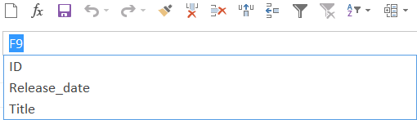

If we select one of them it will highlight the appropriate range.

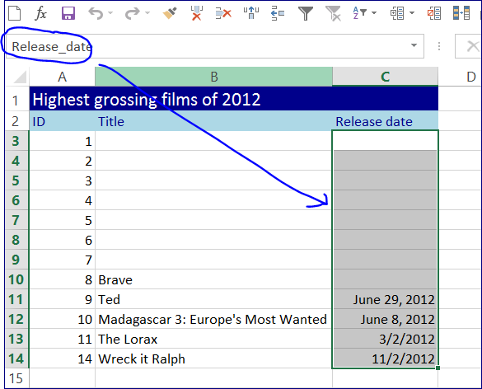

### Refer to Range Names in VBA

Sub ReferToRangeNames()

Range("**ID**").Font.Italic = True

[**Title**].Font.Color = rgbDarkBlue

End Sub

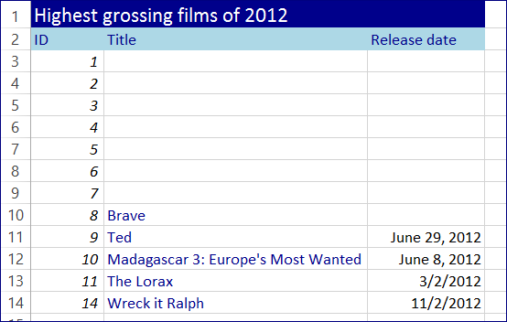

### Referring to Cells Relatively

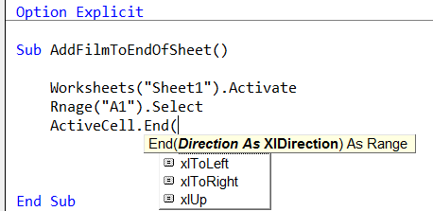

Sub AddFilmToEndOfSheet()

Worksheets("Sheet1").Activate()

'Devide it into 3 steps

Range("A1").Select()

ActiveCell.End(xlDown).Select()

ActiveCell.Offset(1, 0).Select() '(1,0) - one row down and 0 column right

'Make th same in one line of code

Range("A1").End(xlDown).Offset(1, 0).Select()

'Populate cells

ActiveCell.Value = ActiveCell.Offset(-1, 0).Value + 1

ActiveCell.Offset(0, 1).Value = "Lincoln"

ActiveCell.Offset(0, 2).Value = #11/9/2012#

End Sub

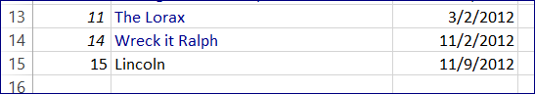

Sub SelectVariableCol()

'Selecting a List from Top to Bottom

Range("A3", Range("A1").End(xlDown)).Select()

Selection.Font.Italic = True

**'Select a column similar to Ctrl + Arrow Down**

Range("B3", Range("B2").End(xlDown)).Select()

Selection.Font.Color = rgbDarkBlue

**'Select a range similar to Ctrl + Arrow Down + Arrow Right**

Range("A3", Range("A1").End(xlDown).End(xlToRight)).Select()

Selection.Interior.Color = rgbAliceBlue

End Sub

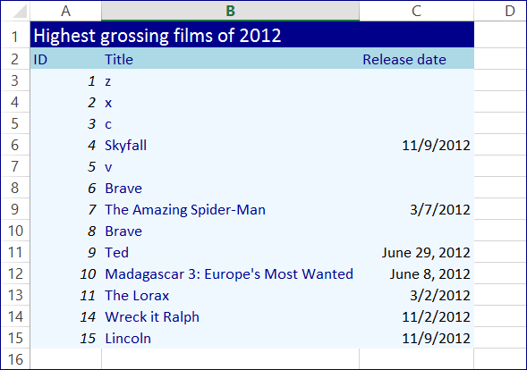

### Selecting an Entire Region of Cells

Such as Ctrl + A

Paste Special

Copy Column Width

Sub CopyFilmList()

### 'Copy and Paste the range

Worksheets("Sheet1").Activate()

Range("A1").CurrentRegion.Copy()

Worksheets("Sheet2").Activate()

Range("A1").PasteSpecial()

### 'Adjust column width

Range("A1").PasteSpecial(xlPasteColumnWidths)

End Sub

### Copying Cells to a Destination

We can provide the destination in the same statement where we have COPY.

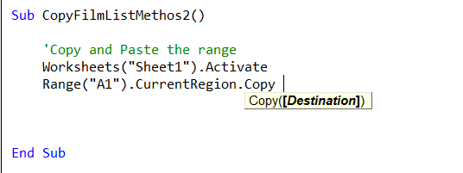

Sub CopyFilmListMethos2()

### 'Copy and Paste the range

Worksheets("Sheet1").Activate()

Range("A1").CurrentRegion.Copy(Worksheets("Sheet3").Range("A1"))

### 'Autofit columns width

Worksheets("Sheet3").Activate()

Columns("B:C").AutoFit()

### 'Another way to autofit columns

Range("A:B").EntireColumn.AutoFit()

End Sub

